**IM3080 Design and Innovation Project (AY2021/22 Semester 1)**

**Individual Report**

Name: Sherlyn Teng

Group No: 7

Project Title: joiNTU

**Contributions to the Project**

**1. Design**

Figma Design

**Week 1 – Week 3: Supermarket app**

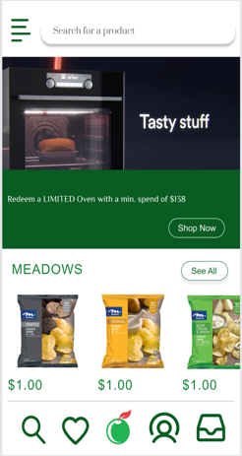 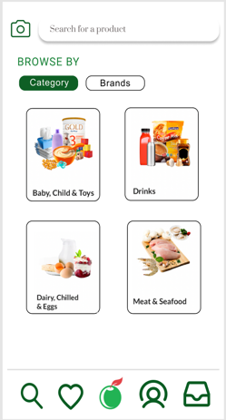 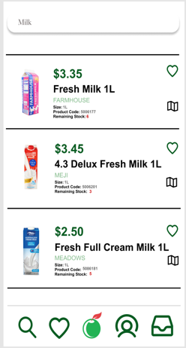

**Week 3-4: joiNTU app first draft design**

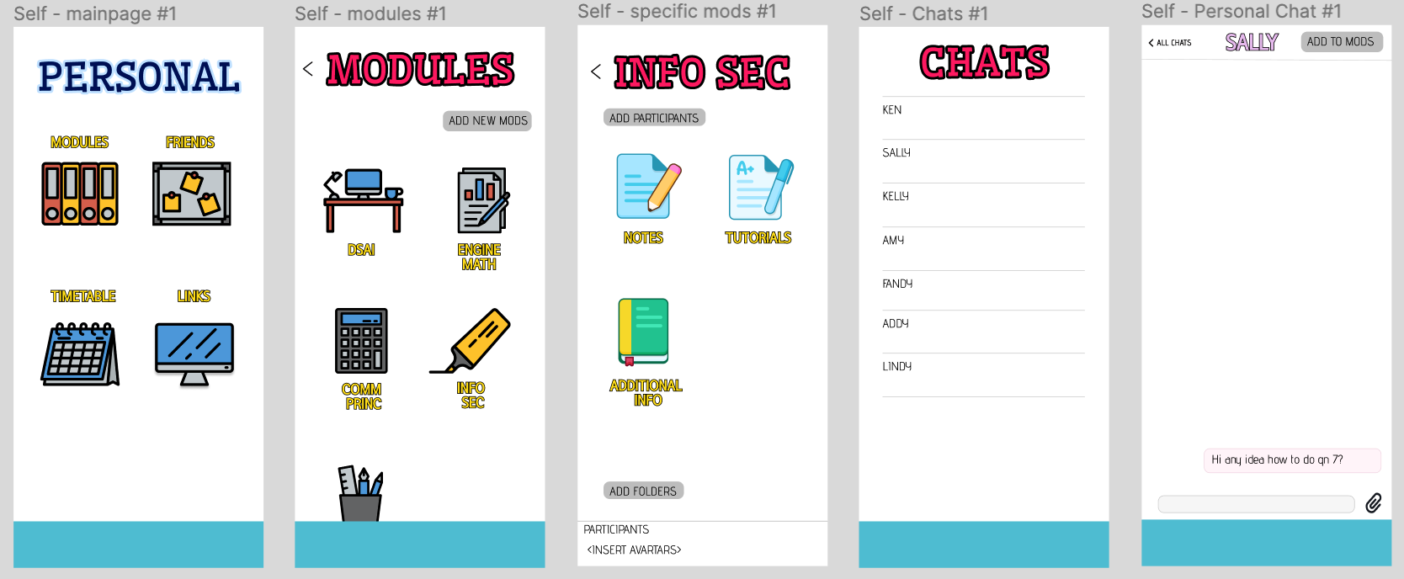

**Week 4-6: NTU 1.0**

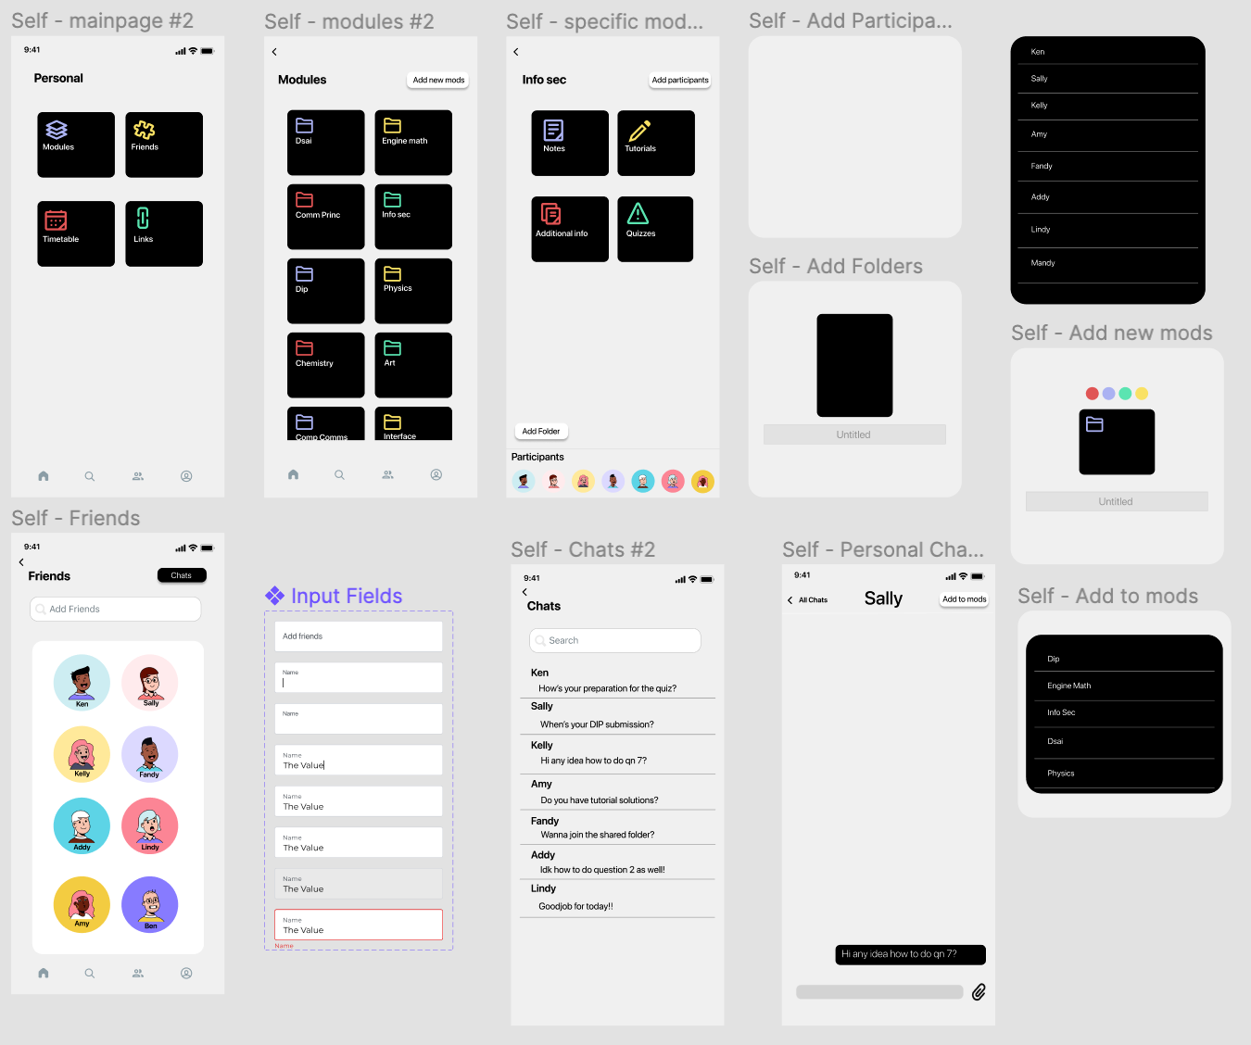 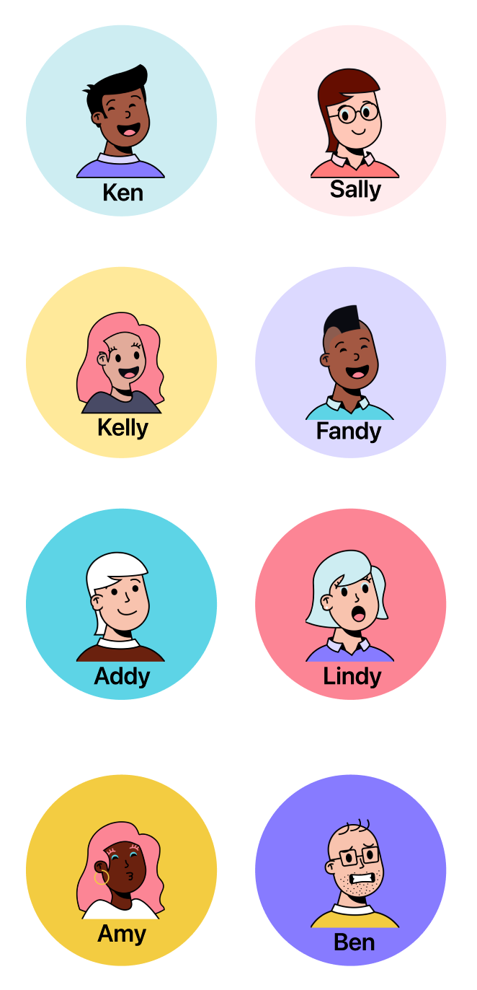 Avartar: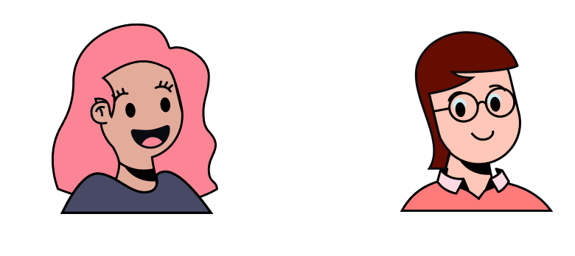

**Week 6 onwards – Final Design**

Flow of the application

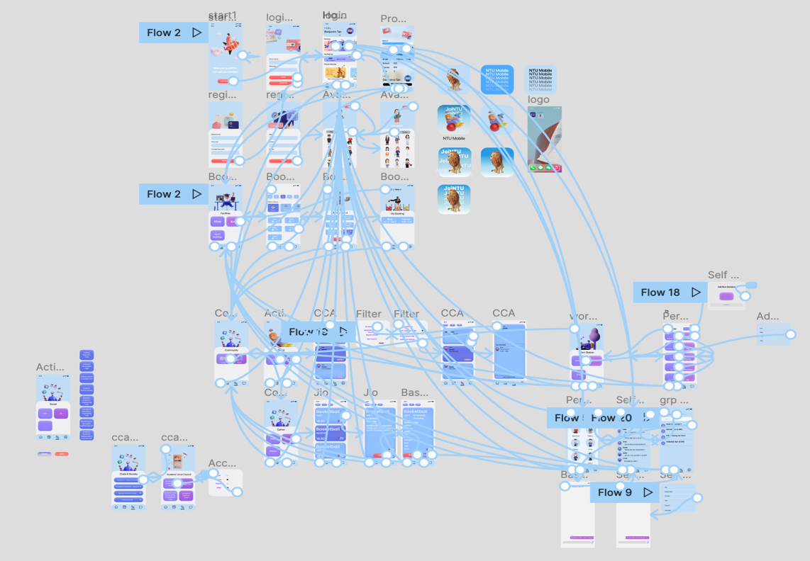

I did the Work Station, Friends and Avatar Selection of the application.

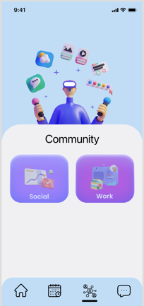 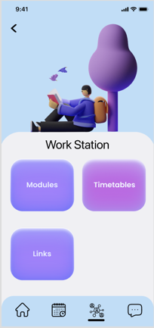 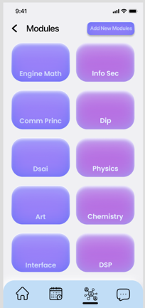 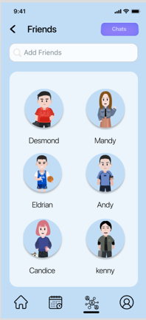 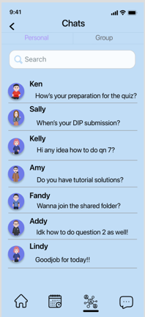 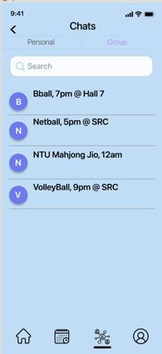

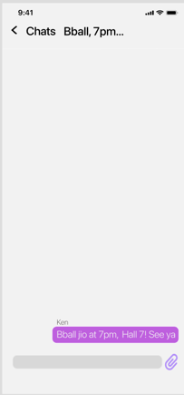 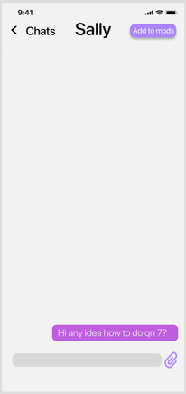 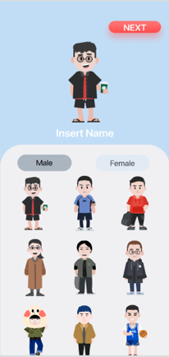 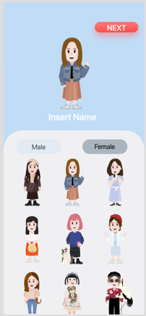

**2. Poster**

My idea:

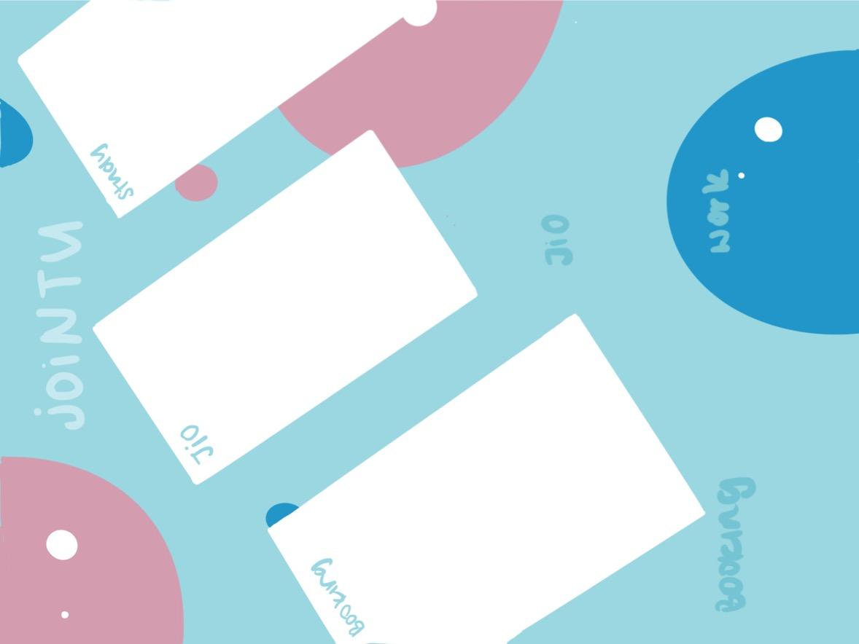

Helped to edit and touch up the final poster that the group has chosen

**3. Group Report**

Did the “background and motivation”, “objectives”, “review of technology 3.1”, “ Conclusion and Recommendation” write up

**4. Presentation**

Week 8 presentation

**Reflection on Learning Outcome Attainment**

**Reflect on your experience during your project and the achievements you have relating to at least two of the points below:**

1. Engineering knowledge
2. Problem Analysis
3. Investigation
4. Design/development of Solutions
5. Modern Tool Usage
6. The Engineer and Society
7. Environment and Sustainability
8. Ethics
9. Individual and Team Work
10. Communication
11. Project Management and Finance
12. Lifelong Learning

Point 1: Lifelong Learning

Before starting on this project, I had neither the experience nor knowledge of Figma. Therefore, I was worried that I would not be able to do a good job for the design aspect of the application, as the interface plays an essential role in attracting users. However, throughout the process of designing the interface of the application, I dedicated extra time to review tutorial videos, and had many trial and error sessions before finally getting the hang of it. With so many resources available online, I was able to familiarise myself with Figma and was able to contribute a fair bit in coming up with the design of the application.

Additionally, I have also learnt the combination of colors and fonts when come to designing. Using neon color for an application may not be the most idea especially when it comes to educational ones. This is because it may cause users to have headaches especially after using the it for too long. Hence it is important to choose the right color and font combination in order to make the application be attractive and user interface friendly.

Point 2: Individual and Team Work

Throughout the 13 weeks, I have learned how to work individually and as a team. Since I contributed in the design aspect of the application, I had to work with my two other peers to come out with the interface. One of the hardest parts at the initial stage was to ensure that our designs were aligned. As we all envisioned different ideas for the application, when presenting to each other, there were many differences between each of our ideas.

Hence, for the first few weeks we took some time to understand our individual styles/ideas. Over the span of these few weeks, we managed to come up with several drafts to propose to our other team members and got them to vote for the most suitable idea.

Additionally, as a group of 11, it has taught me the importance of communication. We had to put in extra effort when explaining our ideas. This was to ensure that there was no miscommunication between each other and that everyone was clear about all the ideas. More people in a group means more inputs/suggestions. Even though some of the group members were not in-charge of the designs, they have kindly provided feedback/input to contribute to the team. We wanted to work with an open mind therefore while generating ideas, we considered their ideas too.

Occasionally, the ideas came in after we finalised the designs. Initially this posed as a challenge. But ultimately, we were able to work around it well. Overall, this process has taught me to have patience while working with others and compromise when the situation arises.